**Respiration rates differ per product**

The respiration rate of a product determine how fast the chemical process occurs. The higher the rate the faster glucose will be transformed and the faster all supplies will be depleted. Therefore, when it comes to storage of fruits and vegetables we want to keep the respiration rates as low as possible without killing the produce.

We will zoom into various ways to do that in a little while. However, we first have to look at all the different types of fruits and vegetables and their influence on the respiration rate. Each variety has a different respiration rate. The respiration rate of a tomato will be very different of that of a carrot which again will be different of that of a strawberry.

It is a lot harder to keep products with a very high respiration rates. They simply run out of energy more quickly. Below you can find some examples of very slow up to very fast respiring products ([USDA](http://www.ba.ars.usda.gov/hb66/respiratoryMetab.pdf)):

* *Very slow*: nuts & dates
* *Slow*: apple, citrus, grape, onion, potato
* *Moderate*: banana, cherry, pear, fig, lettuce, tomato
* *Fast*: strawberry, cauliflower, avocado
* *Very fast*: artichoke, [Brussel sprouts](https://foodcrumbles.com/vegetable-science-cooking-brussel-sprouts/)
* *Extremely fast*: broccoli, mushroom, spinach, sweet corn

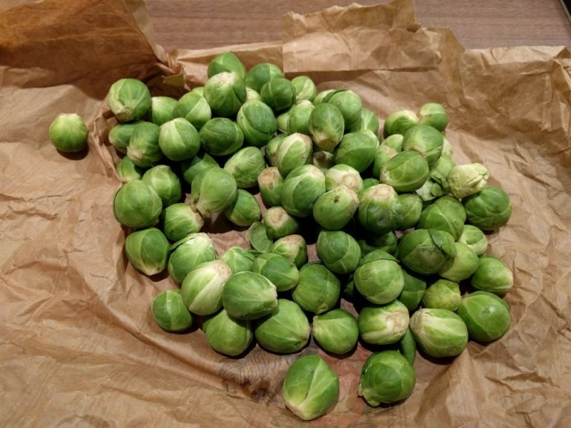Brussel sprouts have a very high respiration rate.

*Definitions*

The definitions used above use the respiration rates (mg CO2kg-1 hour-1) at 5°C. The categories are as follows: very slow (<5), slow (5-10), moderate (10-20), fast (20-40), very fast (40-60), extremely fast (>60).

*Units*

The unit of respiration rate is: *mg CO2kg-1 hour-1.*The rate describes the amount of carbon dioxide produced per kg of produce in 1 hour. As you can see in the equation above, carbon dioxide is formed during respiration. If you know this amount you can also calculate how much glucose has been converted.

**Influencing respiration rate of fruits and vegetables**

Since respiration is just a chemical reaction, you can influence the rate of its reaction in various ways:

1. Temperature: the chemical reaction goes faster at a higher temperature, though, when the temperature is too hot, enzymes will break down and respiration will stop.
2. Oxygen concentration: The reaction needs oxygen, so if there is no oxygen, no respiration occurs. In general, less oxygen leads to a slower reaction rate.
3. Carbon dioxide concentration: The influence of carbon dioxide concentration depends strongly on the fruit or vegetable. Some might increase in respiration rate, whereas with others more carbon dioxide might lead to slower reactions.
4. Stress in a vegetable: Yes, vegetables can be stressed, for instance if they are cut or damaged. This will initiate all sorts of reactions, including those that accelerate respition.
5. Ripening: Some fruits (and vegetables) continue to ripe after they have been harvested (climacteric fruits). During ripening the respiration rate might increase or decrease, depending on the product. This can also be linked with ethylene concentrations.

Source : <https://foodcrumbles.com/respiration-fruits-vegetables/>

**MY input:**

* **respiration rate depends on the concentration of oxygen in the atmosphere so we need to find the respiration rate of various fruits under standard atmospheric condition**
* LOOK at **Table 8** in the file **Modelling respiration rate of fresh fruits and vegetables for modified**
* Making a table or LIST (in python) of fruit and its firmness and respiration rate is one way
* Another way is to take the ripness output of a fruit and the estimate firmness using it and respiration rate can be estimated from the **table** **8** given in the file **Modelling respiration rate of fresh fruits and vegetables for modified**
* **Temperature will be taken from the whether API , now it will depend on the language we chose to implement this whole shelf life program, most probably in java**